H.T No
Regulations:
A18

Sreenidhi Institute of Science and Technology
(An Autonomous Institution)
Code No: 7AC02 Date: 01-Nov-2021 (FN)

B.Tech I-Year I- Semester External Examination, Oct/Nov-2021 (Supplementary)
NETWORK ANALYSIS (ECE)

Time: 3 Hours Max.Marks:70

Note: a) No additional answer sheets will be provided.
b) All sub-parts of a question must be answered at one place only, otherwise it will not be valued.
c) Missing data can be assumed suitably.

ANSWER ANY 5 OUT OF 8 QUESTIONS. EACH QUESTION CARRIES 14 MARKS.

Bloom's Cognitive Levels of Learning (BCLL)

Remember | L1 | Apply | L3 | Evaluate | L5
Understand | L2 | Analyze | L4 | Create | L6

 |  |  | BCLL | CO(s) | Marks
1. |  | Using star – delta transformation, find the voltage to be applied across AN in order to drive a current of 2A, into the circuit.  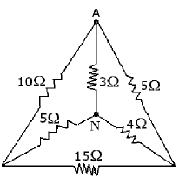 | L3 | CO1 | [14M]
2. | a) | For the following graph, write tie set matrix by choosing 1, 2, 3, 6 branches as tree branches.  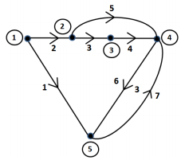 | L3 | CO2 | [7M]
 | b) | Define and explain the Tie set and a basic Tie set. | L2 | CO2 | [7M]
3. | a) | Obtain expression for Inductance of a coil. | L3 | CO3 | [7M]
 | b) | Three inductances L_{A} = 9H, L_{B} = 4H and L_{C} = 16H are connected in series while the first two coils are in series addition having a coupling coefficient of 0.5 while the second and third coil are in series opposition with a coupling coefficient of 0.6. Determine the equivalent inductance and derive the formula. | L3 | CO3 | [7M]
4. | a) | Determine the current through the 2Ω resistor using the Superposition principle  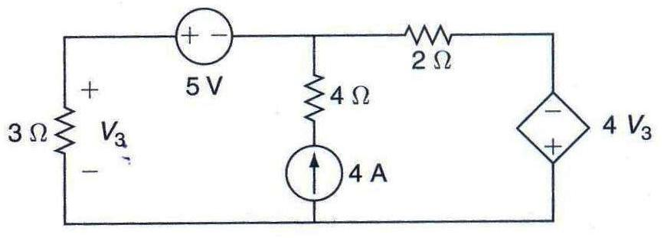 | L3 | CO4 | [7M]
 | b) | State and explain Thevenin’s theorem with an example. | L2 | CO4 | [7M]
5. | a) | Explain h-parameters in two port network. | L3 | CO5 | [7M]
 | b) | The Z-parameters of two port network are Z₁₁=15, Z₂₂=24 and Z₁₂=Z₂₁=6 Determine ABCD parameters. | L3 | CO5 | [7M]
6. | a) | Explain the transient response of series RLC circuit for sinusoidal excitation. | L2 | CO6 | [7M]
 | b) | Explain the transient response of a series RL circuit. | L2 | CO6 | [7M]
7. | a) | Derive the expression for energy stored in the capacitor. | L3 | CO1 | [5M]
 | b) | Define and explain the Cut set and a basic Cut set. | L2 | CO2 | [5M]
 | c) | Obtain an expression for coefficient of coupling | L3 | CO3 | [4M]
8. | a) | Explain the locus diagram of series R-L circuit when L is variable. | L4 | CO4 | [7M]
 | b) | Find the current through the 3Ω resistor using the Superposition theorem.  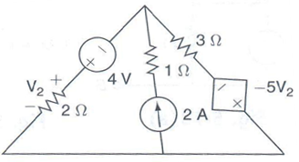 | L3 | CO5 | [7M]

-- 00 -- 00 –

